Cooking Classes
Group Members:
- Muhammad Abdullah (2025-GA-10)
- Muhammad Faizan (2025-GA-11)
- Muhammad Sagheer (2025-GA-14)
- Abdul Rehman (2025-GA-46)
- Abdul Hadi (2025-GA-51)
Course Name:
- Application of Information and Communication Technology LAB (AICTL)
Course Instructors:
Dr. Ramsha Khalid
Muhammad Waleed (T/A)
Date:
January 06,2026
Executive Summary
Our cooking class website is designed to offer beginners and home cooks professional culinary training through structured courses, detailed recipes and practical cooking guides. It focuses on building essential cooking skills, kitchen confidence and an understanding of modern culinary standards. The platform supports personal growth and potential career opportunities in the food industry by providing accessible, high-quality learning for anyone interested in improving their cooking abilities. This website designs different types of fonts and provides different recipes to make secure the professional chef. Some videos help us in how to make food at home and some video help in professional way.
Objectives and Scope of the Cooking Class Website
The objective of our cooking class website is to provide high quality and professional education through structured courses, detailed recipes and online cooking techniques for beginners and professionals. It aims to promote skills development, creativity and confidence in cooking. The future scope includes expanding online classes, certified programs, international cuisines, live workshops, and collaborations with chefs and continuous learning in the culinary arts.
Site Structure & Navigation
- Home
- About
- Courses
- Recipes
- Contact us
Home:
Welcome to Cooking classes website. Turn your Passion for Cooking into a Professional skill!
Explore our cooking courses, recipes and expert tips to elevate your cooking skills. Whatever you are beginner or looking to refine your technique, we have got you covered.
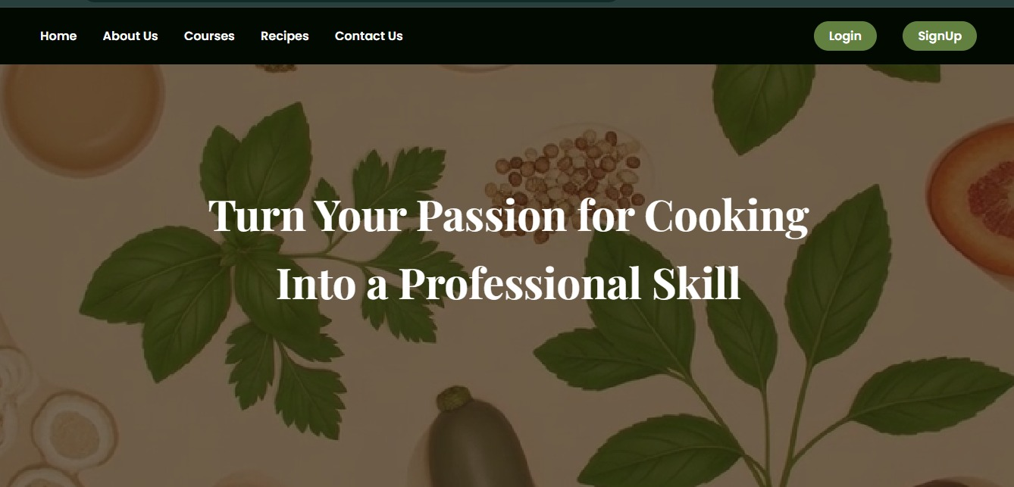

Explore
- About Us: Learn about our Mission and Culinary skills
- Courses: Learn our courses to improve your cooking techniques form basic to advance level.
- Recipes: View our recipes that helps you to enhance your food taste and also in making.
- Contact Us: Get in touch with us for Queries and collaborations.
Courses:
The purpose of this page is to showcase the cooking courses offer on the website, highlighting what each course teach and its duration. On a cooking website the purpose of a courses is to providing lessons and training that guide learners to develop specific culinary skills. Each course has specific goals:
- Teach particular cooking techniques or recipes.
- Help students to improve their cooking abilities from basic to advance level.
- Offer a set time frame for completing the lessons and techniques.
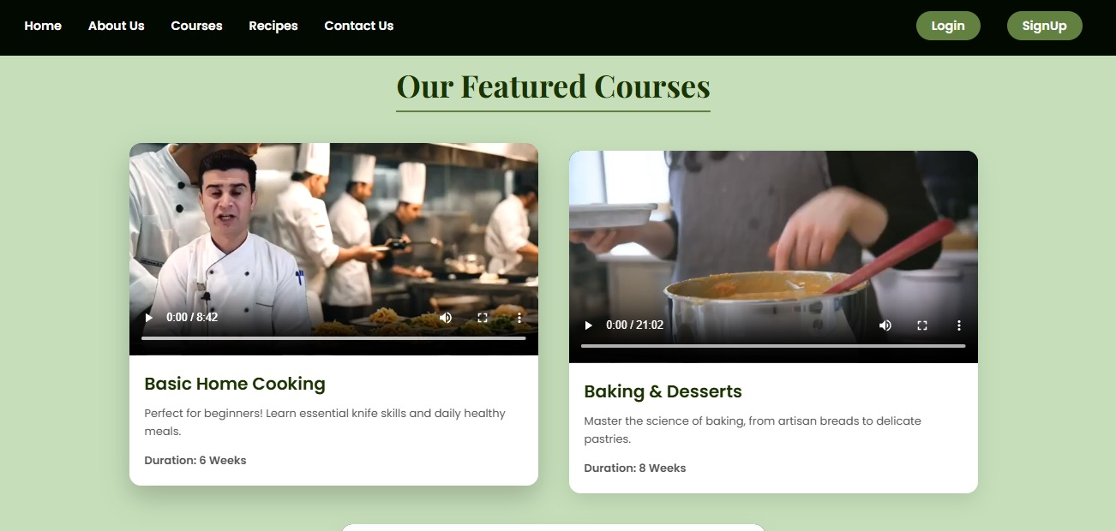
Recipes:
We provide step by step instruction to prepare delicious food and healthy food.
A typical Recipes includes:
- Ingredients: List of items needed to make a dish.
- Method: Steps to prepare and cook the food.
- Preparation Time: Time requires to make the dish.
Recipes cover various type of Dishes:
- Everyday Meals: Quick and easy to make food.
- Desserts: Sweets treats and bake goods.
- Special Occasion Dish: Meals for Festival and gathering
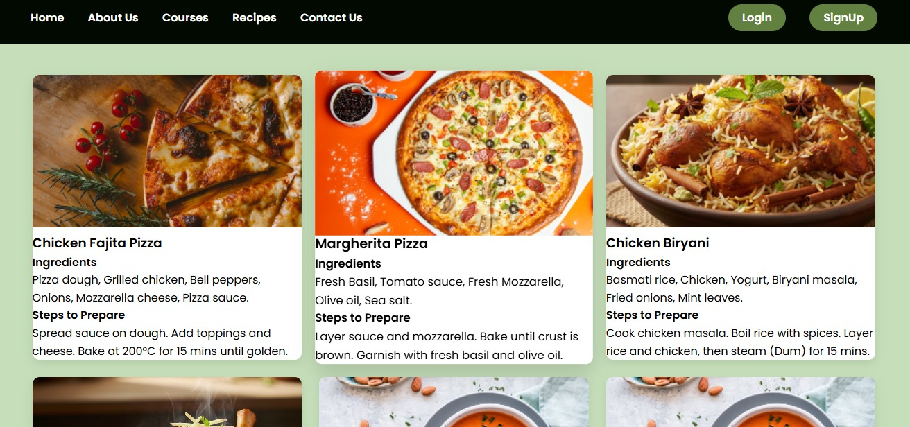
Contact Us:
Get in touch with us. We love hearing from our foodies! Whatever you have a question about a recipes, want to collaborate or just want to say hello, we are here for you .
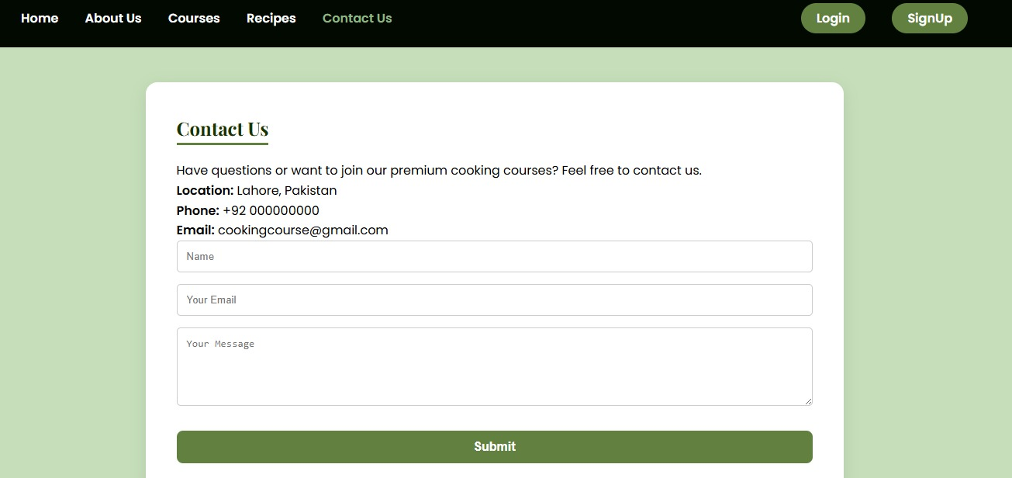
How to run/publish a website?
First finalize your website files and ensure all pages, stylesheets, images, and links work correctly on your local computer. Next, choose a hosting platform (such as GitHub Pages, ssssor a traditional web hosting service) and create an account. Upload your HTML and CSS files to the hosting server using the platform’s dashboard or an FTP tool, making sure the main file is named index.html. After uploading, connect a domain name if needed or use the free subdomain provided by the host. Finally, test your website online on different devices and browsers to confirm that it loads properly and looks as expected
The main Courses for Website is:

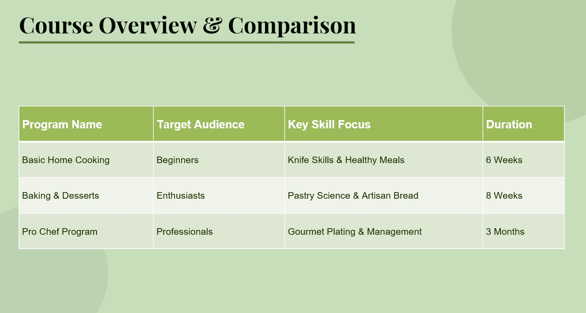
The Excel sheet :

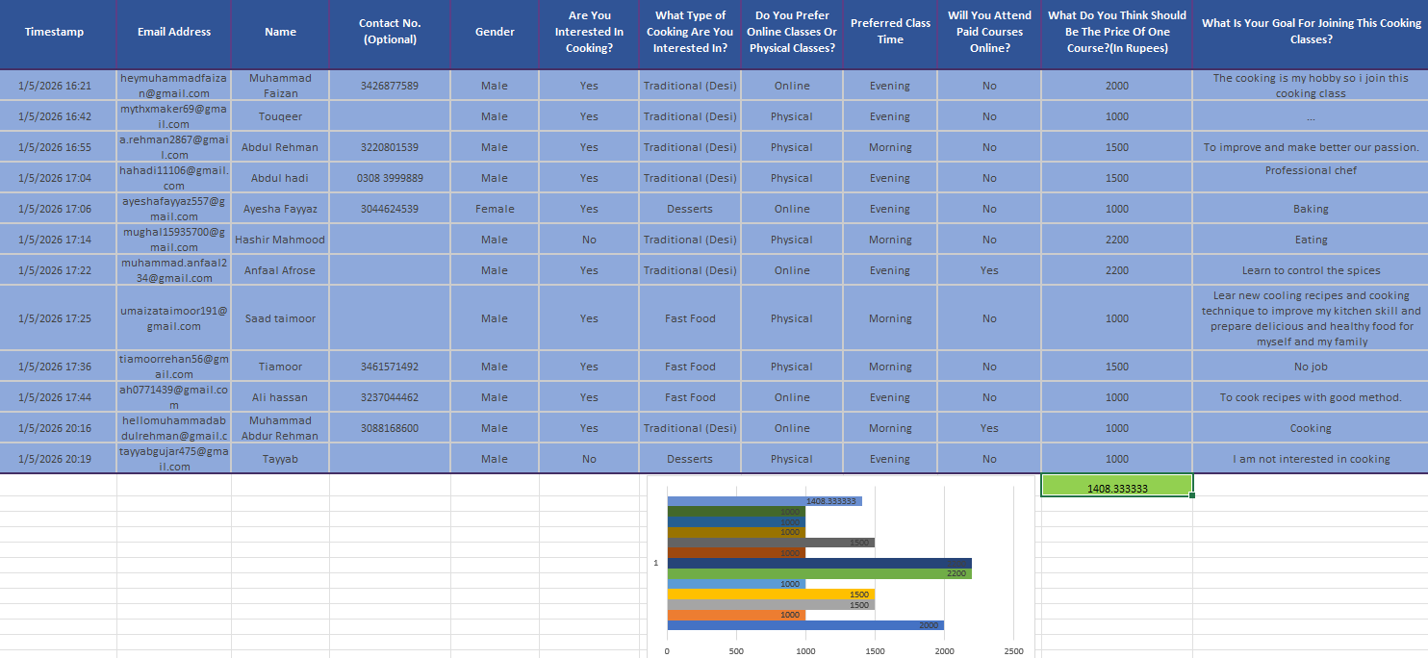
Conclusion:
Our academy is more than a school. It’s a community where passion meets profession. We provide the skills that transform kitchens into stages for excellence.

